**“It’s beginning to look a lot like Christmas.”**

Instructions

Please use this map to drive around town and view all the homes and businesses that have entered the decoration competition. Once you have found your favorite three, rank them in order on the ballot below and return it to the Village office at 209 S. Sheldon, or email your favorite three to [villagemanager@edmore.com](mailto:villagemanager@edmore.com) by close of business on December 29th. Please note that only 2 ballots per household will be accepted.

Locations

|  |  |
| --- | --- |
|  |  |
|  |  |
|  |  |
|  |  |
|  |  |
|  |  |
|  |  |
|  |  |
|  |  |

**Christmas Decoration Competition**

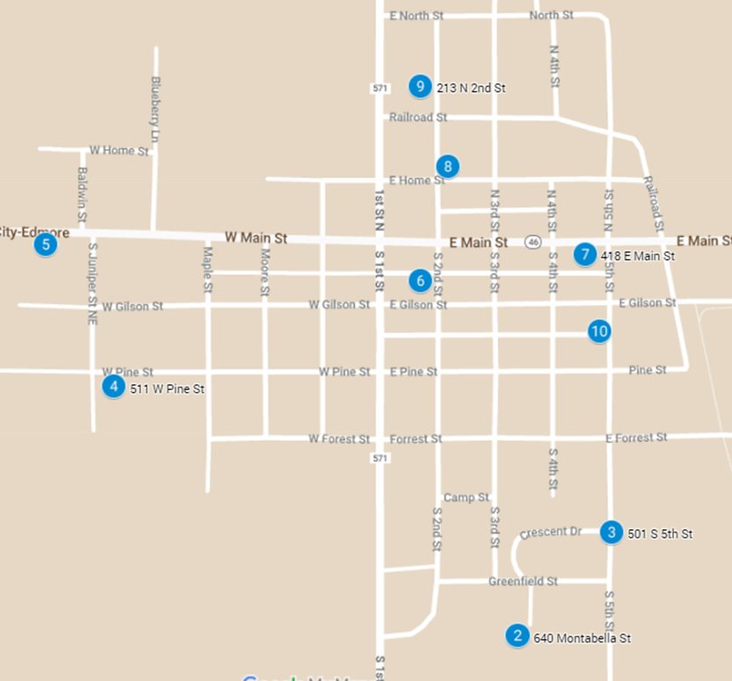

***Ballot***

***Input the location choice***

First: _____________________

Second: ____________________

Third: _____________________

***Voter Information***

Name: _________________________________

Signature: ______________________________

Address: _______________________________